Blessed Sacrament Families - Save the Date!

Dear families,

Mark your calendars! The fun and excitement of a Scholastic Book Fair is coming to our school! To adapt to our changing needs, Scholastic has developed a Virtual Book Fair to provide an opportunity for our students and families to experience the joy of reading together.

So save the date! Our Scholastic Virtual Book Fair will take place from Monday, November 2 to Monday, November 9!

When it’s time to shop, visit our school’s Virtual Book Fair
site using this link:

https://virtualbookfairs.scholastic.ca/pages/5149000

Before our Fair begins, click the link to:
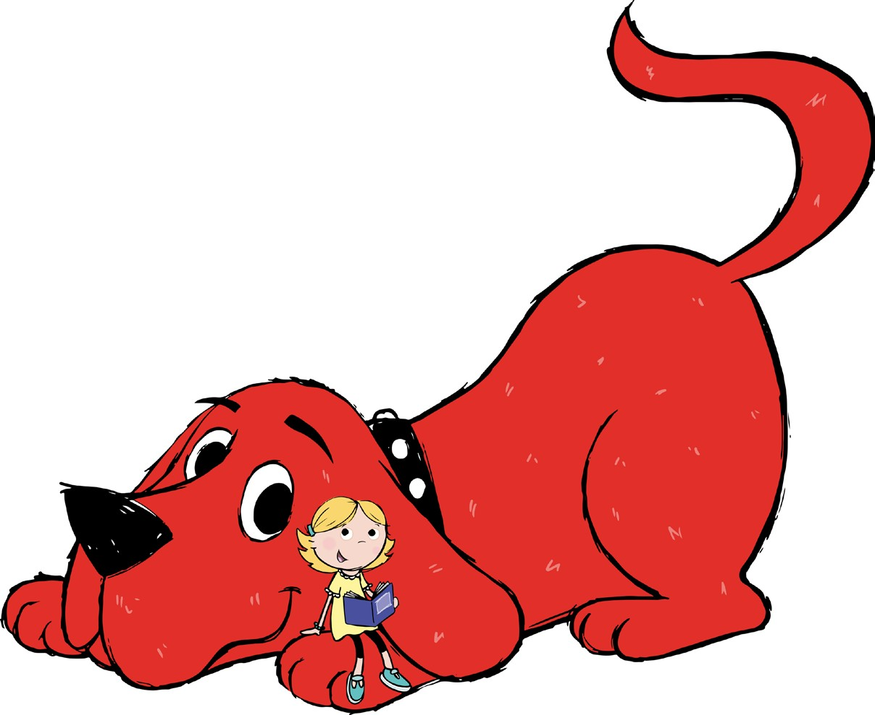
- SAVE it to your browser
- WATCH videos of popular new titles
- PREVIEW our Featured Books

Watch for news leading up to our Scholastic Virtual Book Fair!

Happy reading!

Christine Gohn
Library Resource Technician

